Send Email OTP
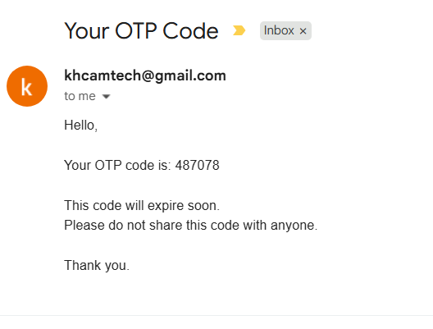
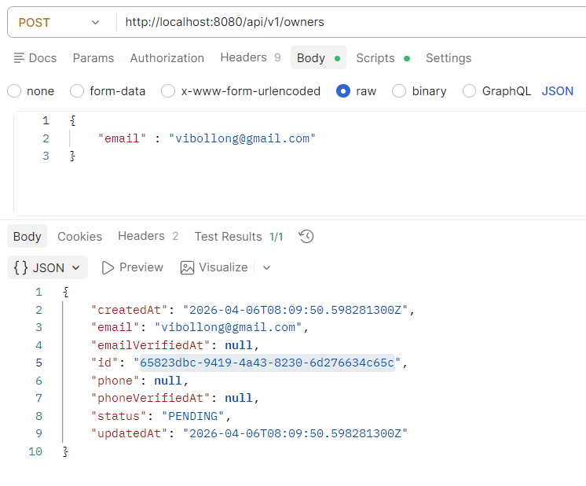

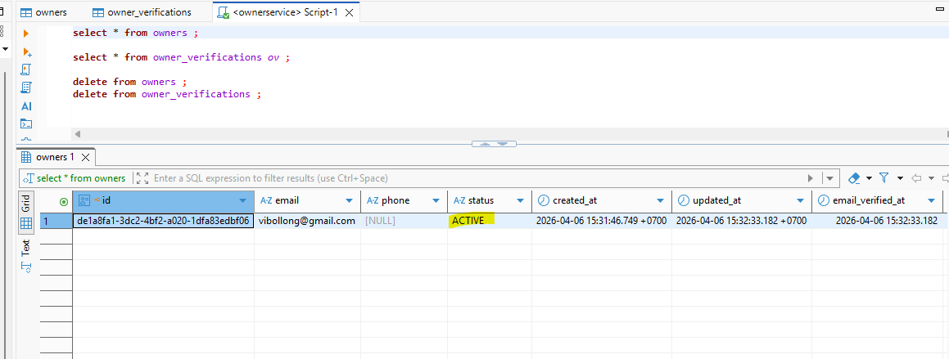

- Add dependency
<!-- Send Email -->
<dependency>
<groupId>org.springframework.boot</groupId>
<artifactId>spring-boot-starter-mail</artifactId>
</dependency>

- Application.property

mail:
host: smtp.gmail.com
port: 587
username: khcamtech@gmail.com
password: outc slcc smmr ypjd
properties:
mail:
smtp:
auth: true
starttls:
enable: true

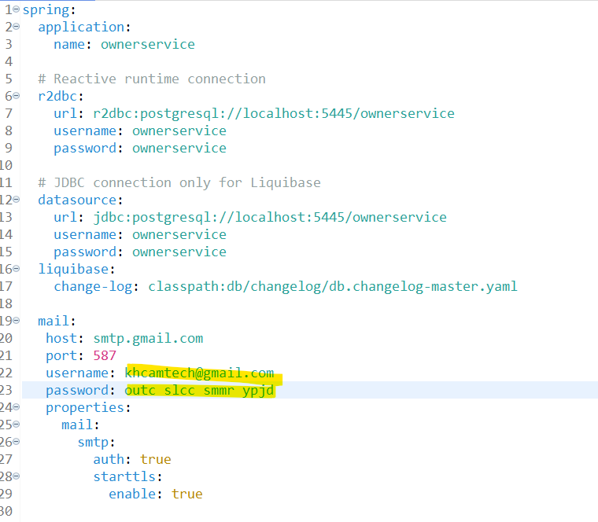

- Setup email to get app password
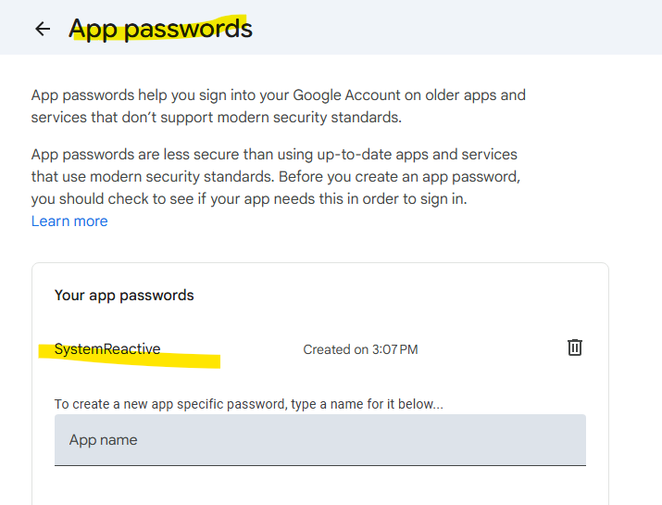

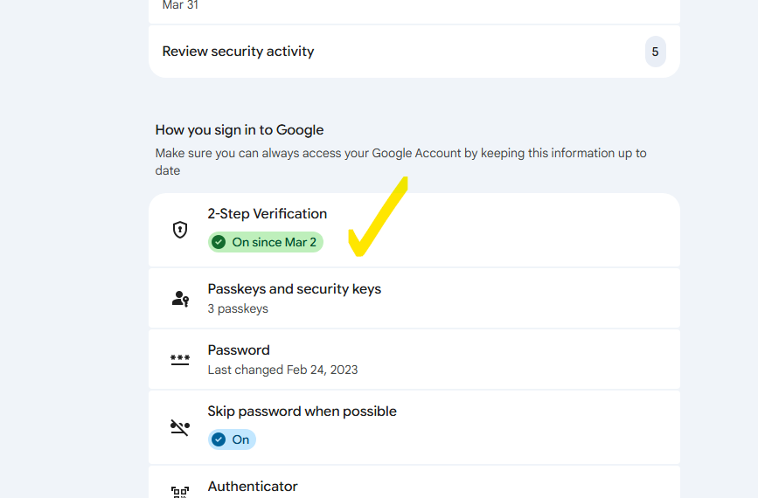

Then after we get the 2-step verification we can create app password

